INVENTORY & SALES MANAGEMENT SYSTEM
A PROJECT REPORT
SUBMITTED BY
Roll Number | Registration Number | Student Code | Student Name
26102410035 | 26102000157 | BWU/MCA/26/039 | Jeet Sarkar
Of in partial fulfillment for the award of the degree
MASTER OF COMPUTER APPLICATION
IN
DEPARTMENT OF COMPUTATIONAL SCIENCE

BRAINWARE UNIVERSITY
398, Ramkrishnapur Road, Barasat, North 24 Parganas, Kolkata - 700 125

ABSTRACT
The Inventory& Sales Management System is a simple Python-based project developed to help small shop owners manage their products, stock, and sales records efficiently. In daily business activities, maintaining proper inventory and sales records is important for avoiding stock shortages and keeping track of business performance. This project provides an easy and convenient way to manage product information and record sales.
The main objective of this project is to create a user-friendly system that allows users to add, search, view, and manage product details. Users can enter product information such as Product ID, product name, category, price, and quantity. The system also allows users to update stock, record sales, calculate bill amounts, and view sales history. It helps shop owners keep track of available stock and understand their sales activities.
The project is developed using Python programming language, with the Tkinter library used to create the graphical user interface. CSV files are used to store product and sales information. The project also uses Pandas for processing sales data and Matplotlib for displaying sales analysis through graphs. It demonstrates fundamental programming concepts such as variables, conditional statements, loops, functions, classes, and object-oriented programming.
The Inventory & Sales Management System reduces the effort required to maintain product and sales records manually. It makes everyday shop management easier by keeping information organised and providing basic sales analysis. This project is useful for small shop owners who want to manage their inventory and sales in a simple and systematic way. In the future, the system can be enhanced by adding database integration, user login facilities, advanced sales reports, and additional inventory management features.
In conclusion, the Inventory & Sales Management System is a basic yet useful application that demonstrates how Python programming can be used to solve real-world problems related to product management, stock maintenance, and sales recording.

TABLE OF CONTENTS

Chapter / Section | Title | Page No.
LIST OF TABLES |  | i
LIST OF FIGURES |  | i
LIST OF ABBREVIATIONS |  | Ii
1. INTRODUCTION |  | 1-3
1.1 | Project Background and Motivation | 1
1.2 | Problem Statement | 1
1.3 | Proposed Solution | 2
1.4 | Scope of the Project | 2-3
2. OBJECTIVES |  | 4
3. PROJECT PLANNING |  | 5-6
3.1 | Need for Systematic Planning | 5
3.2 | Development Methodology (Agile Scrum) | 5
3.3 | Work Breakdown Structure (WBS) | 5-6
3.4 | Feasibility Study | 6
3.5 | Resource & Tool Identification | 6
4. REQUIREMENT ANALYSIS |  | 7-10
4.1 | User Requirements | 7
4.2 | Functional Requirements | 7
4.3 | Non-Functional Requirements | 7-8
4.4 | Hardware and Software Specifications | 8
4.5 | Data Requirements and Formats | 8
4.6 | Comparative Study of Existing Systems | 9
5. SYSTEM FLOW & DESIGN |  | 10-15
5.1 | System Architecture | 10
5.2 | Context Level Diagram (DFD Level 0) | 10-11
5.3 | Detailed Data Flow Diagram (DFD Level 1) | 11-12
5.4 | Use Case Representation | 12
5.5 | Entity-Relationship / Data Modeling | 13
5.6 | Program Logic Flowchart | 13
6. PROPOSED DESIGN & IMPLEMENTATION |  | 14-15
6.1 | Architectural Layering | 14
6.2 | Core Module Decomposition | 14-15
6.3 | Data Persistence & Serialization Strategy | 15
6.4 | Visual Reporting Engine | 15
7. EXPERIMENTAL RESULTS & TESTING |  | 16-17
7.1 | Testing Methodology | 16
7.2 | Unit and Functional Test Cases | 16
7.3 | Analytical Computations & Verification | 17
7.4 | Visualization Output Evaluation | 17
8. FUTURE SCOPE |  | 18
9. CONCLUSION |  | 19
REFERENCES |  | 20

LIST OF FIGURES & TABLES

TABLES:- Page No.
- Table 1.1: System Functional Scope Matrix 2-3
- Table 3.1: Development Stage Distribution 5
- Table 4.1: Functional Requirements Specification 7
- Table 4.2: Non-Functional Quality Attributes 7-8
- Table 4.3: Comparative Matrix of Inventory Management Systems 9
- Table 7.1: Comprehensive Test Cases and Expected Results 16
FIGURES:-
- Figure 5.1: System Architecture Diagram 10
- Figure 5.2: Context Level Diagram (DFD Level 0) 11
- Figure 5.3: Detailed Data Flow Diagram (DFD Level 1) 11
- Figure 5.4: Use Case Diagram 12
- Figure 5.6: Program Logic Flowchart 13
- Figure 6.4:Category-wise Sales Graph 15
- Figure 6.5: Monthly Sales Trends Graph 15

LIST OF ABBREVIATIONS

Acronym | Definition
GUI | Graphical User Interface
CSV | Comma-Separated Values
OOP | Object-Oriented Programming
DFD | Data Flow Diagram
WBS | Work Breakdown Structure
ID | Identification
UI | User Interface
IDE | Integrated Development Environment
Tkinter | Tk Interface
API | Application Programming Interface

CHAPTER 1:INTRODUCTION
1.1 Project Background and Motivation
Inventory management is an important part of running a small shop. Shopkeepers need to maintain product details, check available stock, record sales and keep track of daily business activities. Managing all these records manually can take time and may lead to mistakes.
The Inventory & Sales Management System is developed using Python to make these tasks easier. It provides a simple graphical interface where users can add products, view and search product details, manage stock, record sales and check sales history.
The main motivation behind this project is to reduce manual work and make product and sales records easier to maintain. It also helps in understanding how Python programming, object-oriented concepts, file handling and data analysis can be used to solve a real-world business problem.
1.2 Problem Statement
Managing products and sales manually can create several problems for small shops. Maintaining records in registers or separate files makes it difficult to keep information updated and organised.
The main problems identified are:
  - Manual Record Keeping: Recording product details and sales manually takes time and may lead to mistakes.
  - Stock Management: It can be difficult to keep track of available product quantities and update stock after each sale.
  - Sales Recording: Calculating sales amounts and maintaining transaction records manually can result in errors.
  - Sales Analysis: Without proper records and analysis, it becomes difficult to understand total sales and identify product-wise sales performance.
To solve these problems, this project develops a simple Python-based Inventory & Sales Management System that helps users manage products, update stock, record sales and view basic sales analysis in one application.

1.3 Proposed Solution
The proposed system is structured around an Object-Oriented software paradigm implemented in Python 3. It provides:
- Interactive Graphical Interface: A user-friendly desktop application (main.py) developed using Tkinter, allowing users to add products, search records, manage stock, record sales and view reports.
- Encapsulated Data Model: A dedicated product representation (product.py) that maintains product ID, product name, category, price and quantity through the Product class.
- Persistent Local Storage: A file-based storage system (inventory.py) that uses CSV files to maintain product records, update stock quantities and manage inventory-related operations.
- Sales Management Module: A dedicated sales module (sale.py) that records transaction details, including sale ID, product information, quantity, price, total amount and date.
- Analytical Engine: A dedicated analysis module (analysis.py) that uses Pandas to calculate total sales and perform product-wise, category-wise and monthly sales analysis.
- Visual Reporting Subsystem: A graphical report generator using Matplotlib that presents sales information through bar and line charts for better understanding of business performance.
1.4 Scope of the Project
The scope of the Inventory & Sales Management System covers the main activities required to manage products, maintain stock records, record sales and analyse business performance. The system is designed mainly for small shops and uses a Python-based desktop application with local CSV file storage.
Table 1.1: System Functional Scope Matrix
Functional Domain | In Scope | Out of Scope (Future)
Product Management | Adding products with Product ID, Name, Category, Price and Quantity. Searching and viewing product records. | Barcode scanning and automatic product registration.
Inventory Management | Updating stock quantities, checking available stock and identifying low-stock products. | Automatic stock ordering and supplier integration.
Sales Recording | Recording sales details, calculating sales amounts and maintaining sales history. | Online payment processing and e-commerce integration.
Data Storage | Local file storage using CSV files for product and sales records. | Cloud-based databases and online data synchronisation.
Sales Analysis | Calculating total sales and analysing product-wise, category-wise and monthly sales. | AI-based sales forecasting and machine-learning predictions.
Visualization | Generating bar and line charts using Matplotlib to display sales information. | Real-time interactive web-based dashboards.
Error Handling | Checking duplicate product IDs, missing products and insufficient stock through exception handling. | Advanced security systems and multi-factor authentication.

The project focuses on providing basic inventory and sales management facilities through a simple desktop application. Advanced features such as cloud storage, barcode scanning, online payments and automated sales prediction may be considered for future development.

CHAPTER 2:OBJECTIVES
The main objective of the Inventory & Sales Management System is to develop a simple and user-friendly Python application that helps small shops manage their products, stock and sales records efficiently. The system aims to reduce manual work, maintain organised records and provide basic sales analysis.

2.1 Primary Objective
The primary objective of the Inventory & Sales Management System is to develop a simple Python-based desktop application that helps small shops manage product details, maintain stock records, record sales transactions and analyse sales information efficiently.

2.2 Secondary Objectives
- Easy Product Management: Add, view and search product details.
- Efficient Stock Management: Update stock and identify low-stock products.
- Sales Record Maintenance: Maintain sales transaction records.
- Reduced Manual Work: Reduce manual effort in managing records.
- Better Business Understanding: Understand sales performance through reports.

2.3 Functional Objectives
- Product Management: Add, view and search products.
- Inventory Management: Update and check stock.
- Sales Management: Record sales and maintain sales history.
- Sales Calculation: Calculate total sales amounts.
- Low-Stock Identification: Identify products with low quantities.
- Sales Analysis: Analyse product-wise, category-wise and monthly sales.
- Graphical Reporting: Generate sales charts using Matplotlib.

2.4 Technical Objectives
- Python Programming: Develop the application using Python.
- GUI Development: Create the desktop interface using Tkinter.
- Object-Oriented Programming: Use Product, Inventory and Sale classes.
- File Handling: Store records in CSV files.
- Data Analysis: Use Pandas for sales analysis.
- Data Visualization: Use Matplotlib for graphical reports.
- Exception Handling: Handle invalid product IDs and insufficient stock.

CHAPTER 3:Project Planning
3.1 Need for systematic planning
Developing an Inventory & Sales Management System requires proper planning to organise different tasks, manage development time and ensure that all modules work together correctly. Systematic planning helps in completing the project step by step, reducing errors and making the development process easier.
3.2 Development Methodology
The project follows a modular and step-by-step development approach. The work is divided into different stages to develop and test each module properly.
The development process includes the following stages:
- Planning: Identifying the project requirements and deciding the main features.
- Design: Planning the application structure and dividing the project into separate Python files.
- Development: Implementing product management, inventory management, sales recording and data analysis.
- Testing: Checking each module and fixing errors to ensure proper functionality.
- Integration: Connecting all modules and running the complete application.
Table 3.1: Development Stage Distribution
Stage | Scope and Milestone Target | Outcome
Stage 1 | Requirement analysis, project structure design, product class (product.py) and CSV storage setup (inventory.py). | Basic product and inventory management.
Sprint 2 | Development of sales module (sale.py), main application interface (main.py) and sales recording functionality. | Working desktop application with product and sales management.
Sprint 3 | Sales analysis (analysis.py), graphical chart generation, testing, error handling and documentation. | Completed Inventory & Sales Management System.
3.3 Work Breakdown Structure (WBS)
- Product & Inventory Management
- Define the Product class with product details.
- Implement product addition, searching and updating operations.
- Implement stock management and low-stock checking.
- Sales Management
- Develop sales record creation and storage.
- Implement sales amount calculation.
- Maintain sales transaction history.
- Analytical Processing & Reporting
- Develop total sales and product-wise sales analysis.
- Implement category-wise and monthly sales summaries.
- Generate bar and line charts using Matplotlib.
- User Interface & Integration
- Develop the graphical interface using Tkinter.
- Connect all Python modules with main.py.
- Test application functions and handle errors.

3.4 FEASIBILITY STUDY
- Technical Feasibility: The project uses Python, Tkinter, CSV, Pandas and Matplotlib. It requires minimal hardware resources.
- Economic Feasibility: The project uses free and open-source libraries, so the development cost is very low.
- Operational Feasibility: The simple graphical interface makes product, stock and sales management easy for users.
3.5 Resource & Tool Identification
- Technical Feasibility: The project uses Python, Tkinter, Pandas and Matplotlib, which provide the required tools to develop the system.
- Economic Feasibility: Python and the required libraries are freely available, making the project cost-effective.
- Operational Feasibility: The system provides a simple graphical interface for managing products, updating stock, recording sales and viewing reports.

CHAPTER 4:REQUIREMENT ANALYSIS
4.1 User Requirements
- The system shall provide a simple graphical interface to manage products, stock and sales records.
- The system shall allow users to add, search and view product details easily.
- The system shall update stock quantities after every successful sale.
- The user must be able to view sales history and check total sales information.
- The user must be able to view product-wise, category-wise and monthly sales analysis.
- The system shall generate graphical sales reports using Matplotlib.
4.2Functional Requirements
Table 4.1: Functional Requirements Specification
Identifier | Description | Validation Rule
FR-01 | Add new product | Product ID must be unique; product name and category must be provided; price and quantity must be valid.
FR-02 | Display and search products | Display stored product details and allow users to search for products using product information.
FR-03 | Stock management | Update product quantities and prevent sales when sufficient stock is not available.
FR-04 | Record sales | Store sale ID, product details, quantity, price, total amount and date.
FR-05 | Sales analysis | Calculate total sales and generate product-wise, category-wise and monthly sales summaries.
FR-06 | Chart production | Generate bar and line charts using Matplotlib to display sales information.
4.3Non-Functional Requirements
Table 4.2: Non-Functional quality Attributes
Criterion | Attribute | Measure / Target
NFR-01 | Performance | The system should perform product searches, stock updates and sales calculations efficiently.
NFR-02 | Portability | The Python application should support execution on compatible operating systems with the required dependencies.
NFR-03 | Data Storage | Product and sales records should be stored locally in CSV files without requiring an internet connection.
NFR-04 | Maintainability | Separate Python modules should make the project easier to understand, update and maintain.

4.4Hardware and Software Specification
- Hardware: Any computer or laptop with a minimum of 4 GB RAM, a dual-core processor and sufficient disk space to store project files and reports.
- Software: Python 3, Tkinter, Pandas, Matplotlib, Visual Studio Code or Python IDLE, and a compatible operating system such as Windows, Linux or macOS.
4.5Data Requirements and Formats
The system uses CSV (Comma-Separated Values) files for storing product and sales information. The data is organised using the following fields:
1. Product Data (products.csv)
- product_id: Unique identifier for each product.
- name: Name of the product.
- category: Category of the product.
- price: Selling price of the product.
- quantity: Available stock quantity.
2. Sales Data (sales.csv)
- sale_id: Unique identifier for each sale.
- product_id: ID of the sold product.
- product_name: Name of the sold product.
- category: Category of the product.
- quantity: Number of units sold.
- price: Price per unit.
- total: Total sale amount.
- date: Date of the sales transaction.

4.6Comparative Study of Existing Systems
Table 4.3: Comparative Matrix of Inventory Management Systems
Capability / Feature | Commercial Inventory Software | Spreadsheet Models | Proposed Python Inventory & Sales Management System
Hosting Model | Cloud-based or Desktop | Local Files | Local Desktop Application
Network Dependency | May require Internet | Not Required | Not Required
Resource Overhead | Medium to High | Low | Low
Inventory Management | Automated | Manual Entry | Automated through Python
Sales Analysis | Built-in Reports | Manual Calculations | Automated using Pandas
Graphical Reports | Built-in Charts | Manual Chart Creation | Automated using Matplotlib
Code Extensibility | Limited | Limited | Extensible Python Codebase
CHAPTER 5: SYSTEM FLOW & DESIGN
5.1 System Architecture
The application adheres to a clean Three-Tier Architecture configured entirely on the local client machine:
- Interface Layer (main.py): Captures user commands, renders console tables, and handles loop dispatching.
- Business & Processing Logic (tracker.py, analytics.py, visualizer.py): Executes core algorithms, mathematical aggregations, file updates, and Matplotlib plotting pipelines.
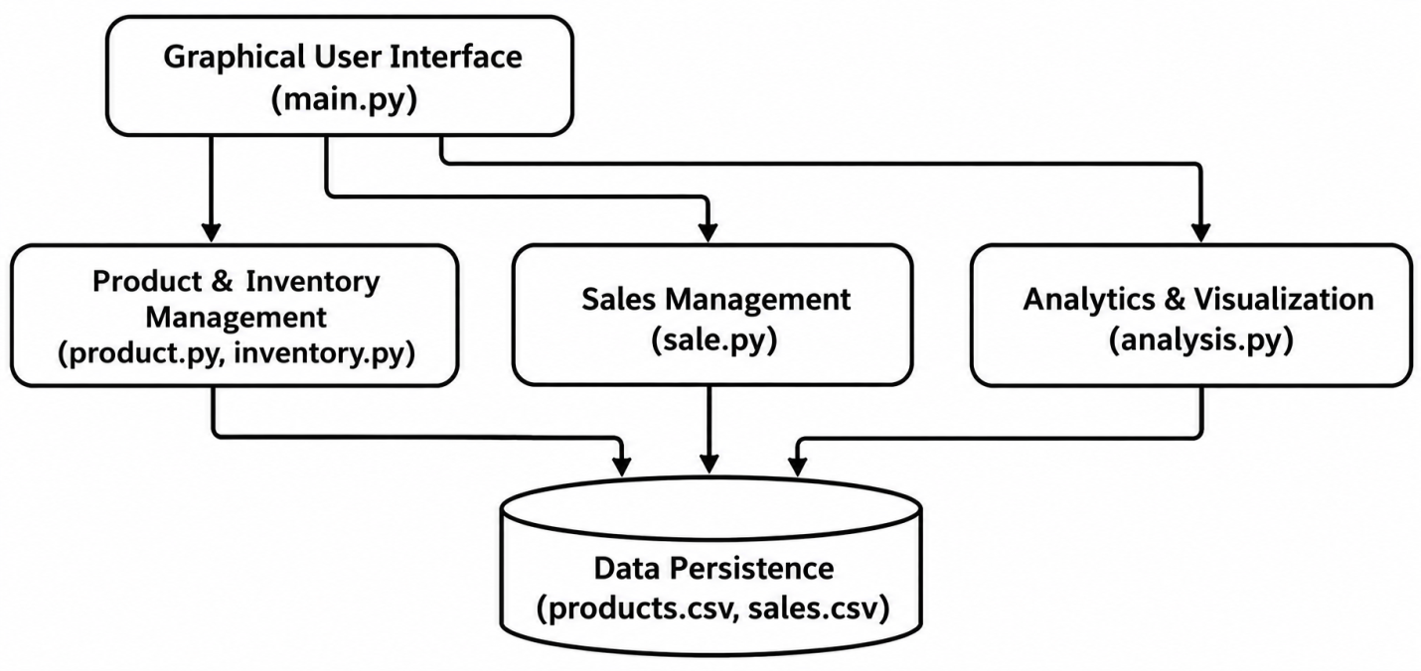
- Storage Tier (data/expenses.csv, data/expenses_export.json): Persists normalized records on the physical filesystem.
Figure 5.1: System Architecture Diagram

5.2Context Level Diagram (DFD LEVEL 0)
The Context Level Diagram shows the overall working of the Inventory & Sales Management System. It represents the interaction between the user and the system, including the input of product and sales details and the output of inventory information and sales reports.
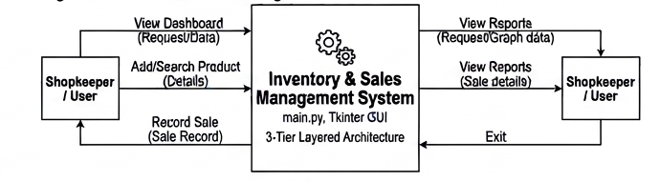
Figure 5.2: Context Level Diagram (DFD Level 0)

5.3Detailed Data Flow Diagram (DFD LEVEL 1)
The Detailed Data Flow Diagram (DFD Level 1) represents the internal working of the Inventory & Sales Management System. It shows how the user interacts with different processes, how product and sales information is processed, and how records are stored in CSV files.
The system is divided into four main processes:
- Product Management: Allows the user to add, view and search product details.
- Inventory Management: Manages stock quantities, updates available stock and identifies low-stock products.
- Sales Management: Records sales transactions and updates product stock after a sale.
- Sales Analysis: Processes sales records to calculate total sales and generate product-wise, category-wise and monthly reports.
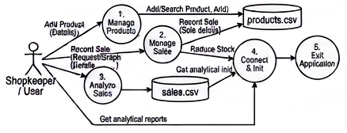
Figure 5.3: Detailed Data Flow Diagram (DFD Level 1)

5.4Use Case Representation
The Use Case Diagram represents the interaction between the shopkeeper and the Inventory & Sales Management System. It shows the different activities that the user can perform through the graphical user interface.
Main Actor:
- Shopkeeper / User: The person who operates the system to manage products, inventory and sales records.
Main Use Cases:
- View Dashboard
- Add Product
- View Products
- Search Products
- Record Sale
- View Sales History
- Manage Stock
- Check Low Stock
- View Sales Analysis
- Generate Graphical Reports
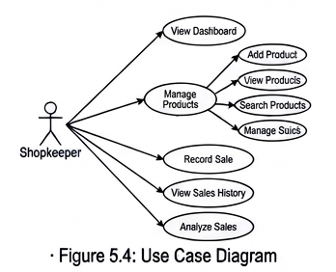

5.5 Entity-Relationship/Data Modeling
The Entity-Relationship (ER) Diagram represents the structure of the data used in the Inventory & Sales Management System. It shows the relationship between the Product and Sale entities and explains how product and sales information is maintained in the system.
Main Entities:
- Product: Stores product information such as Product ID, Name, Category, Price and Quantity.
- Sale: Stores sales transaction information such as Sale ID, Product ID, Product Name, Category, Quantity, Price, Total Amount and Date.
5.6Program Logic Flowchart
The Program Logic Flowchart represents the step-by-step working process of the Inventory & Sales Management System. It shows how the application starts, accepts user operations, processes information and displays the results
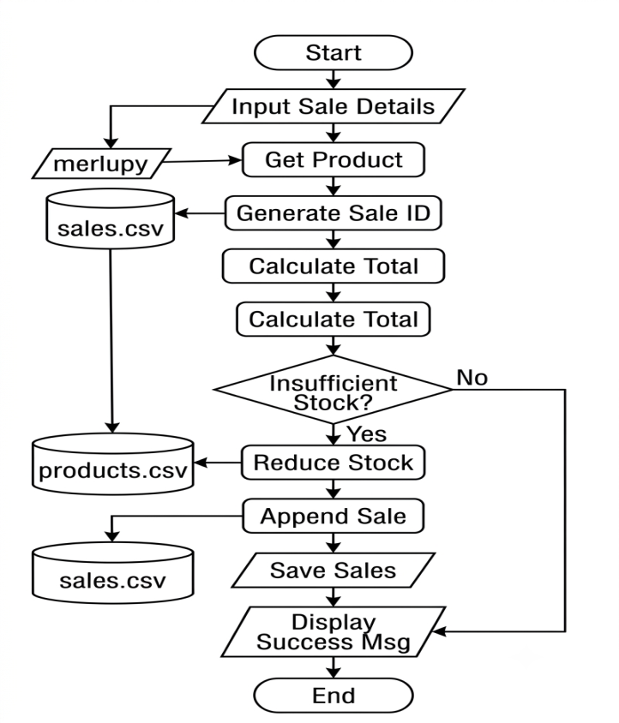
Figure 5.6: Program Logic Flowchart
CHAPTER 6:PROPOSED DESIGN & IMPLEMENTATION
6.1 Architectural Layering
The Inventory & Sales Management System follows a three-layer architecture. Each layer performs a specific function to keep the application organised and easy to maintain.
- Presentation Layer (main.py): Provides the graphical user interface using Tkinter and allows users to manage products, stock and sales.
- Business Logic Layer (product.py, inventory.py, sale.py, analysis.py): Handles product details, inventory operations, sales records and sales data analysis.
- Data Storage Layer (products.csv, sales.csv): Stores product and sales information locally in CSV files.
6.2Core Module Decomposition
1. Main Application Module (main.py)
- Creates the graphical user interface using Tkinter.
- Displays the dashboard and navigation menu.
- Connects different modules of the application.
- Allows users to manage products, stock, sales and analytics.
2. Product Module (product.py)
- Defines the Product class.
- Stores Product ID, product name, category, price and quantity.
- Converts product information into dictionary format.
3. Inventory Module (inventory.py)
- Manages product records.
- Adds and searches for products.
- Updates and reduces stock quantities.
- Checks low-stock products.
- Handles duplicate products and insufficient stock errors.
- Stores product information in CSV files.
4. Sales Module (sale.py)
- Defines the Sale class.
- Stores sales transaction details.
- Maintains Sale ID, Product ID, product name, category, quantity, price, total amount and date.
- Converts sales information into dictionary format.
5. Sales Analysis Module (analysis.py)
- Uses Pandas to process sales records.
- Calculates total sales.
- Performs product-wise, category-wise and monthly sales analysis.
- Generates graphical reports using Matplotlib.
6.3Data Persistence & Serialization Strategy
- Product Data (products.csv): Stores product ID, product name, category, price and available quantity.
- Sales Data (sales.csv): Stores sale ID, product ID, product name, category, quantity, price, total amount and date.
6.4Visual Reporting Engine
Using Pandas, the SalesAnalysis class reads the sales.csv file, converting columns to correct numeric and datetime formats using pd.to_numeric and pd.to_datetime. It aggregates totals utilizing groupby mechanics. Matplotlib then plots these aggregates. Below are sample outputs generated dynamically by the backend:The main functions of the visual reporting engine are:
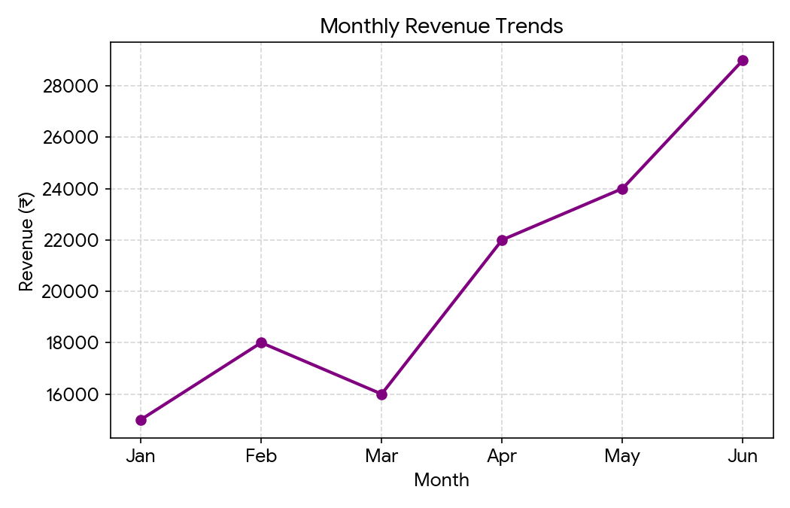
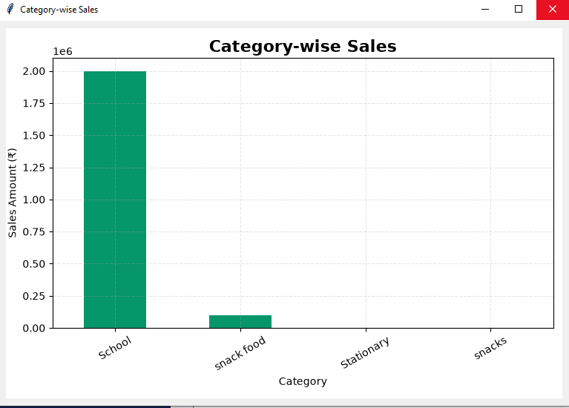
Figure 6.4: Category-wise Sales Bar Chart Figure 6.5: Monthly Revenue Trend Line Chart

CHAPTER 7:EXPERIMENTAL RESULTS & TEXTING
7.1 Testing Methodology
The application underwent both unit-level and functional validation to verify input boundaries, file I/O operations, analytical calculation accuracy, and reporting pipelines.
7.2Unit & Functional Test Cases
Table 7.1: Test Suite Execution and Validation Results
Test ID | Objective | Expected Result | Status
TC-01 | Initialize system without existing CSV files | Files auto-created gracefully in /data directory | PASS
TC-02 | Add valid product (e.g., Apple, Food, 10, 50) | Record appended to memory and CSV | PASS
TC-03 | Add product with duplicate ID | DuplicateProductError raised, UI alert displayed | PASS
TC-04 | Add product with negative price | ValueError raised, transaction rejected | PASS
TC-05 | Record Sale with valid quantity | Sale recorded, stock reduced, CSV updated | PASS
TC-06 | Record Sale exceeding available stock | InsufficientStockError raised, no write performed | PASS
TC-07 | Generate Monthly Sales Chart | Chart PNG generated and saved correctly in /graphs | PASS
TC-08 | Search product in Treeview | Treeview correctly filters non-matching items dynamically | PASS

7.3Analytical Computations & Verification
The system uses Pandas to process sales records stored in the sales.csv file. It calculates total sales and analyses product-wise, category-wise and monthly sales performance. The processed data is used to generate graphical reports using Matplotlib. The analytical results are checked against the stored sales records to ensure accuracy. This process helps users understand sales performance and maintain better business records.
7.4Visualization Output Evaluation
The visualization output of the system is evaluated using Matplotlib charts. Product-wise sales are displayed through bar charts, while monthly sales trends are presented through line charts. These graphs help users compare sales information, understand changes in sales and analyse business performance easily.

CHAPTER 8:FUTURE SCOPE
The following are the 5 most important future improvements for the Inventory & Sales Management System:
- Database Integration: Replace CSV files with MySQL or SQLite to manage larger amounts of product and sales data efficiently.
- Cloud-Based Storage: Introduce cloud storage so that users can access inventory and sales records from different devices.
- Advanced Sales Analysis: Add more analytical features to understand sales performance and identify popular products.
- Sales Forecasting: Use machine learning to predict future sales based on previous sales records.
- User Login and Security: Add a login system with different user roles to protect business information and control access to the application.

CHAPTER 9:CONCLUSION
The Inventory & Sales Management System was developed using Python to make product management, stock maintenance and sales recording easier for small shops. The application provides a simple graphical interface using Tkinter, where users can add products, search records, manage stock, record sales and view sales history. It uses CSV files to store product and sales information locally. Pandas and Matplotlib are used to analyse sales data and generate graphical reports. Overall, this project helped demonstrate the practical use of Python programming, object-oriented concepts, file handling and data visualization in solving a real-world business problem.

REFERENCES
- Python Software Foundation. Python 3 Documentation.
https://docs.python.org/3/
- Python Software Foundation. Tkinter Documentation.
https://docs.python.org/3/library/tkinter.html
- Python Software Foundation. CSV File Handling Documentation.
https://docs.python.org/3/library/csv.html
- Python Software Foundation. Datetime Module Documentation.
https://docs.python.org/3/library/datetime.html
- Pandas Development Team. Pandas User Guide.
https://pandas.pydata.org/docs/user_guide/
- Matplotlib Development Team. Matplotlib User Guide.
https://matplotlib.org/stable/users/index.html
- Microsoft. Visual Studio Code Documentation.
https://code.visualstudio.com/docs

